**Daniel Williamson**

**Project #9**

**4/24/16**

**CS 200**

Project Overview

Purpose:

The purpose of this project was to create a maze generator in assembly using recursion. However, in this project we are simply setting up the methods used for the next project. Our program should print out a 79 x 23 grid of pound characters. We will do all this by using stack-based parameter passing. Which is rather simple in C++, but doing it in assembly proved rather difficult. We also finish it off with some testing to make sure the parameters that are being passed in are within the bounds of the grid.

Approach:

To begin this project, I immediately referred back to project #7 where we created our random number generator. I also used and looked at the skeleton code you provided to essentially place some code from project #7 straight into yours. And as always, I looked toward the internet for some help on programming in Assembly. Once I read up, I began to plan how the program should run. Since you had most of everything pre-programed, the beginning was rather simple. I started with working on creating the grid of pound signs and also created the IsInBounds to check to see if the parameters entered are within the bounds of the grid. Next, I inserted my code for the random number generator from project #7. And lastly I created the XYToIndex.

Results

These are my results:

This is a depiction of the rand method. Using stack-based parameters for passing in.

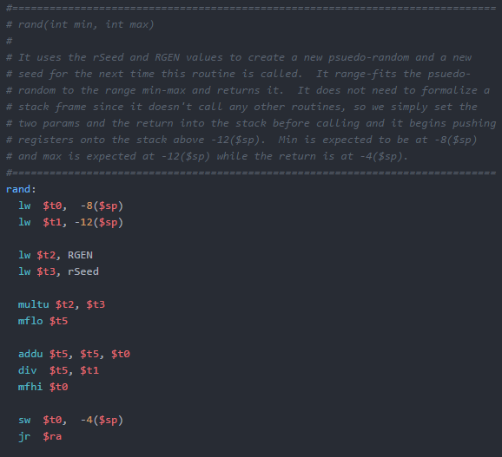

This is a depiction of XYToIndex. Using stack-based parameters for passing in.

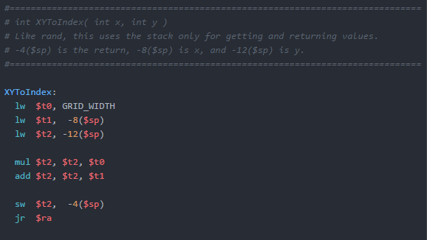

This is a depiction of IsInBounds. Using stack-based parameters for passing in.

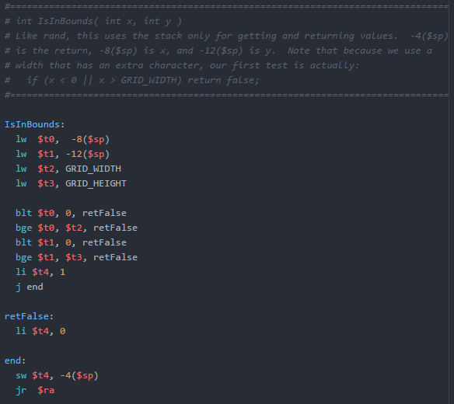

This is a depiction of PrintGrid.

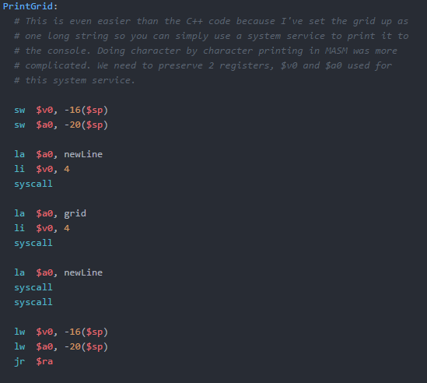

This is a depiction of my testing method. I test XYToIndex and test IsInBounds 4 times. We pass in (0, 0) which is within the bounds and should print out a 1 for true.

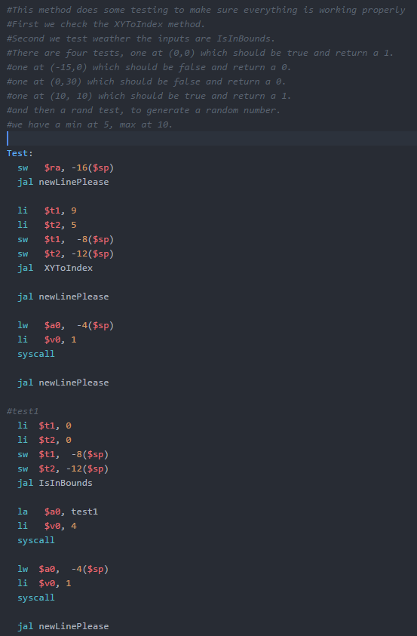

For test #2, we pass in (-15, 0) which is not within the bounds and should print out a 0 for false.

For test #3, we pass in (0, 30) which is not within the bounds and should print out a 0 for false.

For test #4, we pass in (10, 10) which is within the bounds and should print out a 1 for true.

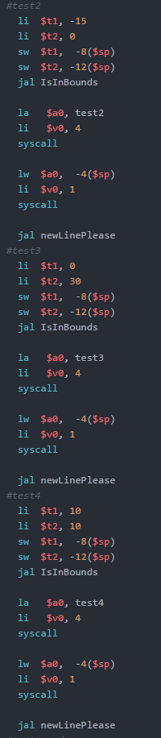

Lastly we have a test for rand. Which generates our random number and prints it out. Also, a newLinePlease, because I was getting tired of typing those four lines over and over again.

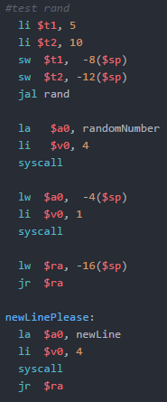

Testing:

Here is our testing. As we can see we have our grid of pound symobls, 79 x 23. Since we used the number 2 billion we get a random number of 3 while having our min at 5 and max at 10. We have our four tests, test 1 should be true, test 2 should be false, test 3 should be false and test 4 should be true. As described above earlier. And lastly since we put in 9 for x and 5 for y, we get a XYToIndex of 409, which we get from y * GRID_WIDTH + x.

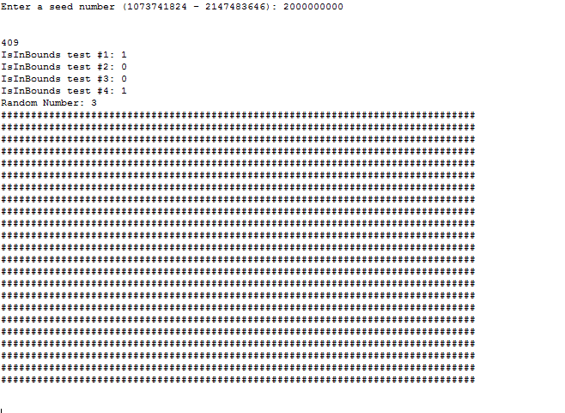

Conclusion

In conclusion this has been somewhat difficult. It was rather short except for the testing portion. As the projects go by, I am becoming more proficient at programming in Assembly. Which makes things go smoother. The hardest challenge I faced for me, was getting the grid to print. I went a totally wrong direction and found a simpler way of doing it.